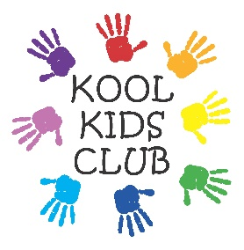
Kool Kids Club Holiday Booking Form

Summer Holidays 2021

Dear Parents/Carers
This booking form is for Summer Holidays 2021.
£27.50 for a full day (7.30am – 6pm)

Should you require childcare during this holiday, please complete this form and return it along with full payment. Please note that we require a minimum of two weeks notice to cancel a session without charge.

Payment by:
Voucher
BACS

Child’s Name …………………………………………………………………………………………………………………….

Email address ……………………………………………………………………………………………………………………

Emergency Contact Name and Number ……………………………………………………………………………

Allergies, Needs or Requirements …………………………………………………………………………………….

Summer  2021 | Full day  7.30am –6pm  £27.50
Friday
23rd
July
Summer  2021 | Full day  7.30am –6pm  £27.50
Monday
26th
July
Tuesday
27th
July
Wednesday
28th
July
Thursday
29th
July
Friday
30th
July

Summer  2021 | Full day  7.30am –6pm  £27.50
Monday
2nd
Aug
Tuesday
3rd
Aug
Wednesday
4th
Aug
Thursday
5th
Aug
Friday
6th
Aug
Summer  2021 | Full day  7.30am –6pm  £27.50
Monday
9th
Aug
Tuesday
10th
Aug
Wednesday
11th
Aug
Thursday
12th
Aug
Friday
13th
Aug

Summer  2021 | Full day  7.30am –6pm  £27.50
Monday
16th
Aug
Tuesday
17th
Aug
Wednesday
18th
Aug
Thursday
19th
Aug
Friday
20th
Aug
Summer  2021 | Full day  7.30am –6pm  £27.50
Monday
23rd
Aug
Tuesday
24th
Aug
Wednesday
25th
Aug
Thursday
26th
Aug
Friday
27th
Aug

Summer  2021 | Full day  7.30am –6pm  £27.50
Monday  30th  Aug | Closed
Tuesday
31st
Aug
Wednesday
1st
Sept
Thursday  2nd  Sept | Closed  (Deep Clean)
Friday  3rd  Sept | Closed  (Deep Clean)
Summer  2021 | Full day  7.30am –6pm  £27.50
Monday
6th
Sept

Children must be registered with our club.
Please ask a staff member for a registration form.

